**SushEat**

**Final Report**

**Submitted by**: Yan Itzhakovich, Lital Cohen and Hen Leibovich

**Supervised by:** Mr. Itai Dabran, Mr. Boris van Sosin, Ms. Marina Minkin, Ms. Nitsan Pri Hadash and Ms. Lina Maudlej

Table of Contents

Abstract 3

1. Introduction 3

1.1 General Project Description 3

1.2 Programming Environment 3

2. Theoretical Background 4

2.1 SushEat machine and mechanics 4

2.1.1 Description 4

2.2 SushEat Electronics 5

2.2.1 Description 6

3. Basic System Functionalities 7

4. Software Implementation 7

4.1 Models 7

4.2 Top-Level View 9

5. Summary 9

6. References 10

7. Appendix A – User Manual 11

# 

# Abstract

# Introduction

The final report explains what has been done and how. The documentation will hold a short description of **SushEat** project, full description of the project, the code files, and important links.

## General Project Description

**SushEat** is a smart automatic sushi machine, suitable for domestic and business use, controlled by an **Arduino** controller, **Xamarin** developed **Android** application and **Azure** based cloud services.

## Programming Environment

**SushEat Android application –** The application was developed upon Visual Studio IDE and Xamarin. An Azure Table Storage was used as a main cloud platform for the application side of the SushEat project. Application was developed in C#, and XAML.

**SushEat electronics –** The Arduino code was written in C, and the electronic components included: 4 step motors (42BYGH4017P1) , 3 step motor controllers (A4988) Arduino UNO, Bluetooth device (HC-05), 12V water pump, 12V and 19V voltage suppliers.

# Theoretical Background

## SushEat machine and mechanics

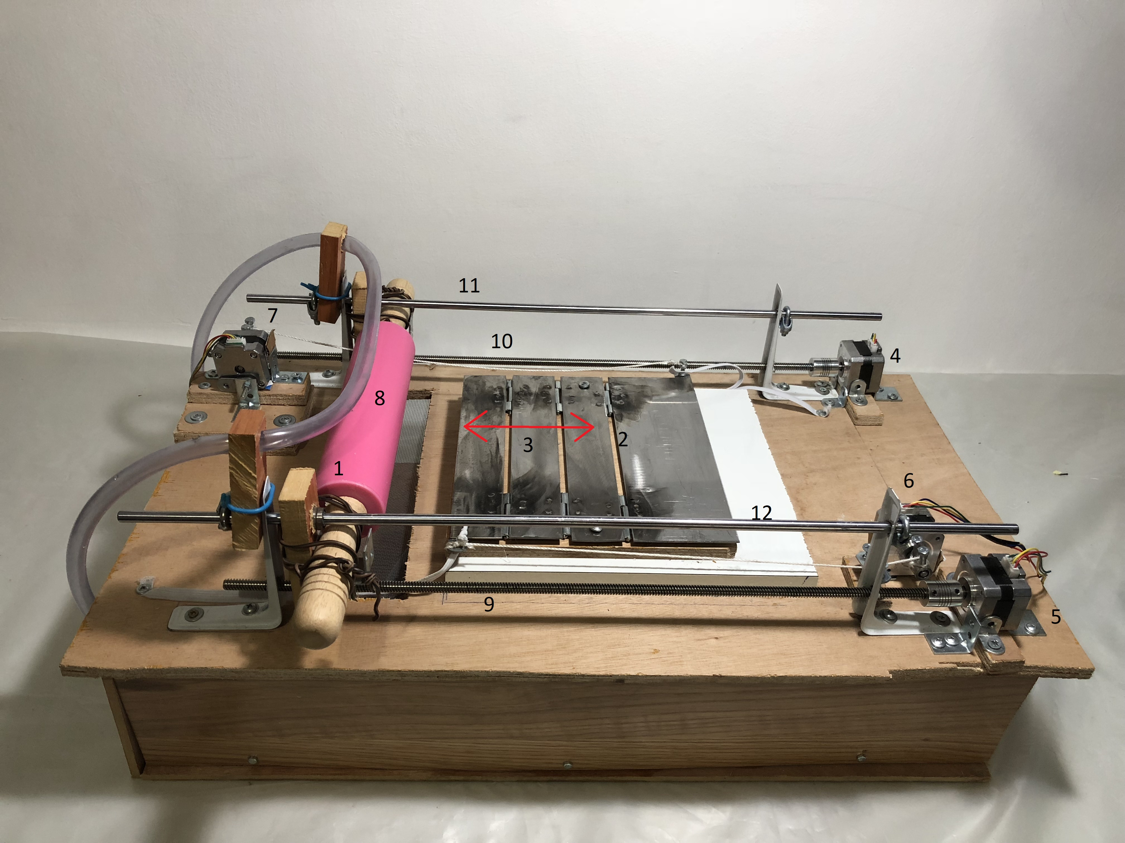

Figure – SushEat machine and mechanics

The figure above depicts the SushEat machine and mechanics.

### Description

The mechanics include the following main components and functions:

**Rolling Pin (1) -** used to spread and layout the rice spread upon the sushi seaweed by the user.

**Step motors (4,5,6,7) –** 2 motors(4,5) are used to move the rolling pin from side to side, 1 motor(7) is used to pull the wide surface (2), and another motor (6) is used to pull the narrow surfaces (3).

**Screwing polls (9,10) –** used to route the rolling pin from side to side.

**Sliding polls (11,12) –** used to stabilize the rolling pin during its motion, by sliding bearings.

**Water tube (8) –** powered by a hidden water pump, that is located inside the wooden hollow space. The water is flowing through the tube, which is perforated along it’s length. The water drips through the holes in the tube and washes the rolling pin. The leaking water is falling through a wooden hole, which is located beneath the rolling pin, such that the water will be reused for another cycle by the water pump.

## SushEat Electronics

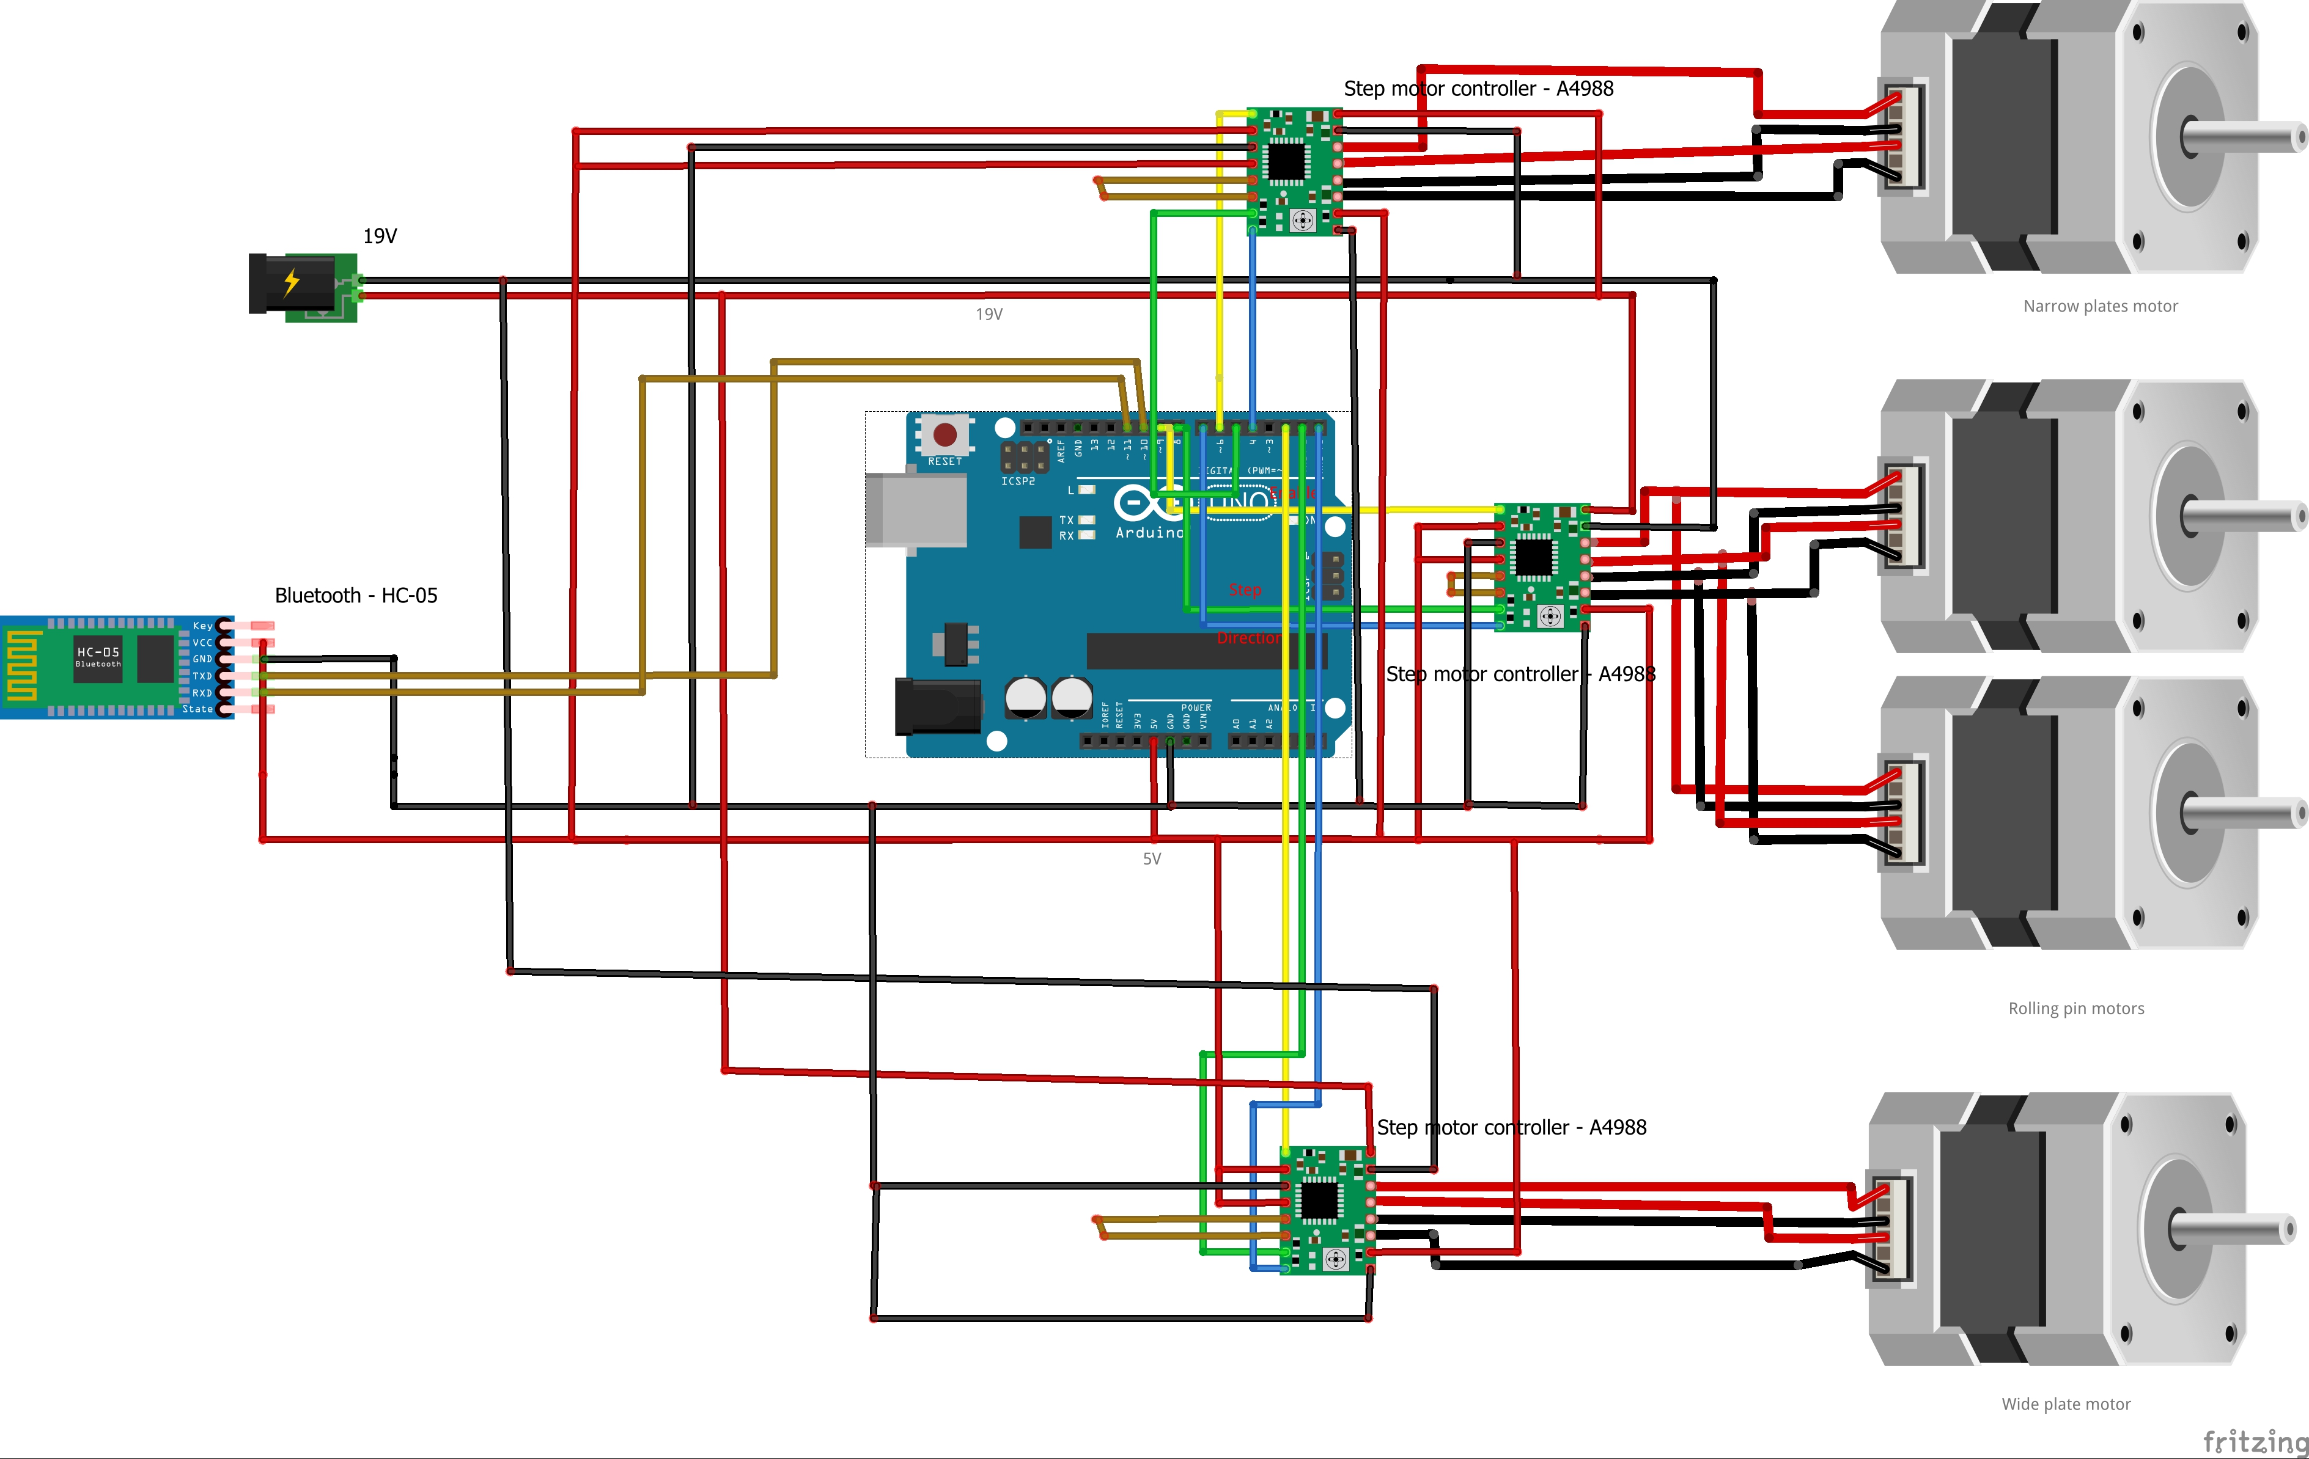

Figure 2 – SushEat electronics scheme

The figure above depicts the SushEat electronics scheme

### Description

The electronics include the following main components and functions:

**Arduino UNO –**

Used to control step motors, and communicate with SushEat application via Bluetooth (HC-05)

**Digital outputs –**

Pin 9 – “Enable” output for rolling pin’s step motors controller

Pin 8 – “Step” output for rolling pin’s step motors controller

Pin 7 – “Direction” output for rolling pin’s step motors controller

Pin 6 – “Enable” output for narrow plates step motor controller

Pin 5 – “Step” output for narrow plates step motor controller

Pin 4 – “Direction” output for narrow plates step motor controller

Pin 2 – “Enable” output for wide plate step motor controller

Pin 1 – “Step” output for wide plate step motor controller

Pin 0 – “Direction” output for wide plate step motor controller

**Serial channel –**

Pin 10 – UART RX for Bluetooth HC-05

Pin 11 - UART TX for Bluetooth HC-05

**Bluetooth device (HC-05) –** Used to mediate between SushEat Android application, and Arduino via UART serial communication.

**Step motor controllers –** used to mediate between Arduino and step motors, to set their direction, and speed.

**Power supplies –** The Arduino is powered by the USB power socket (5V). The step motors are supplied with external 19V voltage supply. The Bluetooth device is supplied with Arduino’s 5V output power supply. The water pump is supplied with external 12V voltage supply.

# Basic System Functionalities

SushEat basic system functionalities are:

**For domestic users –** Via the Android application, the user is able to layout automatically and evenly the rice upon the sushi seaweed, and fold and roll exactly the sushi roll as requested and wished. The result is an exact and even sushi roll. No need to clean manually the rolling pin, the water pump is used just for that, so the user will be able to use another time the machine, with minimum manual adjustments.

**For business users –**

**Restaurant customer –** SushEat Android application enables the restaurant customer to pick and order his sushi roll and send the order to the restaurant.

**Restaurant –** SushEat application enable the restaurant sushi chef to receive a large amount of customer sushi orders, manage them and process them automatically via the machine and application, as described for the domestic users.

**NOTE –** The application as is supports also Google’s Firebase push notifications, that can be sent from the Firebase platform’s console. In practice, this function has been set mainly for future use and a friendlier user interface but has no actual practical use in the current application version.

# Software Implementation

This is the programmer manual:

## Models

The Android application and activity hierarchy is as follows:

**MainActivity.cs – layout: MainPage.axml**

Inherits from Android.App.Activity. loaded when the app starts. The activity is mainly used to establish a onetime connection with the Azure “Customers” table, that stores all the customers’ orders that has been ever made. This connection will be used throughout all runtime of the application. Also, the activity is mainly used for routing the user to select which type of user is he. (domestic, restaurant customer or restaurant chef). Once the user selects his type, this activity finishes, and will never be loaded again.

**PrivateUser.cs – layout: operateMachine.axml**

Inherits from Android.App.Activity. The activity establishes the Bluetooth connection with the HC-05 component and sends Bluetooth messages according to users request (“Roll Me”/”Fold Me”).

**ReastaurantCustomer.cs – layout: Menu.axml**

Inherits from MainActivity. Navigates the users throughout his sushi order. The user is requested to choose his vegetables, sauces, or alternately a restaurant specials rolls (by clicking, the user will be navigated to Veg/Sauce/Rolls activities to pick his orders). Once selected, the user is requested to enter his name and email address (used as a row key in Azure table storage, to uniquely identify the user for future analysis purposes). Once entered his credentials, the user can send his order to the restaurant.

**Veg.cs – layout: Veg.axml**

Inherits from ReastaurantCustomer. Used to collect and add all the vegetable that the user picked, to the cart.

**Sauce.cs – layout: Sauce.axml**

Inherits from ReastaurantCustomer. Used to collect and add all the sauces that the user picked, to the cart.

**Rolls.cs – layout: Rolls.axml**

Inherits from ReastaurantCustomer. Used to collect and add all the specials restaurant’s sushi rolls that the user picked, to the cart.

**RestaurantChef.cs – layout: incomingOrders.axml**

Inherits from MainActivity. The user will see all the current active customer orders that yet to be processed. Each click from the active order list, will navigate the user to a process order page, established by processOrder.cs model. Also, the user can refresh the order list that is presented to him.

**ProcessOrder.cs – layout: processOrder.axml**

Inherits from RestaurantChef. This activity enables the user to operate SushEat machine, the same as for the domestic user that described under privateUser.cs section. In addition, there is a “Mark order as processed” button, that once clicked, removes the orders from the active order list, and updates the “Customers” Azure table accordingly. Once this button is clicked, the user is returned to RestaurantChef activity, with the updated order list.

## Top-Level View

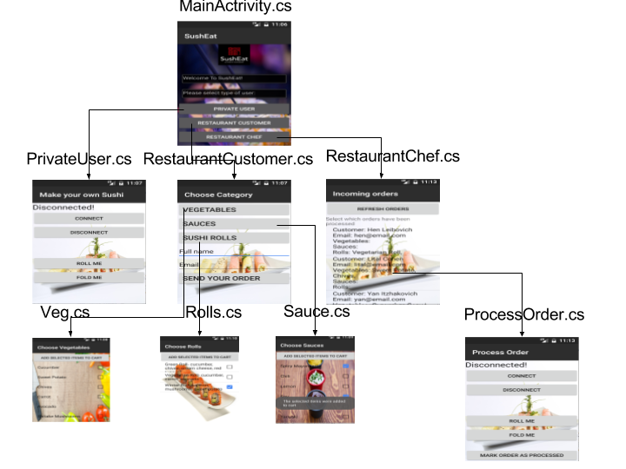

# Summary

This project was mainly designed to help unexperienced sushi lovers, to make a precise and exact sushi roll. In addition, this project enables a restaurant to customer interface model.

Though there are already industrial sushi robots, our project is more suitable for a domestic use, was cheap to develop, and has a friendly user interface and user applications.

# References

* Project’s Github repository - <https://github.com/newein92/SushEat>
* Android application sources - <https://github.com/newein92/SushEat/tree/master/SushEatApp>
* Arduino code - <https://github.com/newein92/SushEat/tree/master/Arduino>
* Seminar presented during semester - <https://github.com/newein92/SushEat/tree/master/Seminar>
* Project’s video - <https://www.youtube.com/watch?v=vQJQsNtysLk>
* Project’s poster <https://github.com/newein92/SushEat/blob/master/PR/SushEat%20Poster.jpeg>
* Project’s icon - <https://github.com/newein92/SushEat/blob/master/PR/SushEat%20icon%20-%20180x180.png>

# Appendix A – User Manual

The following describes the steps needed to operate the machine properly as expected.

**Domestic User Manual:**

1. Pair your Android device “SUSHEAT” device on Bluetooth device list.
2. Open SushEat application.
3. Choose and click on “PRIVATE USER” button
4. Press the “CONNECT” button to connect your application with the machine.
5. Power up machine’s water pump
6. Put sushi seaweed on metal plates.
7. Spread approximately 3-4 spoons of sushi rice.
8. Press the “ROLL ME” button.
9. Wait till the rolling pin has stopped its motion.
10. If desired, press the “ROLL ME” button again to layout the rice again.
11. Put your desired vegetables on the rice.
12. Press “FOLD ME” button and wait until plates have finished their motion.
13. Flip 90 degrees the roll, and press “FOLD ME” again.
14. If desired to strengthen the roll much more, press “FOLD ME” button again.

**Restaurant Customer Manual:**

1. Open SushEat application.
2. Choose and click on “RESTAURANT CUSTOMER” button
3. If desired, choose your vegetable and press “VEGETABLES” button
4. If desired, choose your sauces and press “SAUCES” button
5. If desired, choose the restaurant’s special sushi rolls and press “SUSHI ROLLS” button
6. Enter your name and Email address
7. Press “SEND YOUR ORDER” button and wait to be served with your selected rolls by the restaurant.

**Restaurant Chef Manual:**

1. Open SushEat application.
2. Select the order you desire to process and make.
3. Follow the steps described under **“Domestic User Manual”** section
4. Press “MARK ORDER AS PROCESSED” button.
5. Go back to step 2 if desired.